Study request process
The request for a study will be distributed to all SIGMA members to express interest and availability to participate in the study in the roles of Coordinating Centre, Principal Investigator Centre and/or Research Site.*
Eligibility for requests:
- The SIGMA Consortium is a research network, not a data access provider. Data are accessible in the context of a research project where SIGMA Members have an active role.
- Contact any SIGMA Members directly for data access.
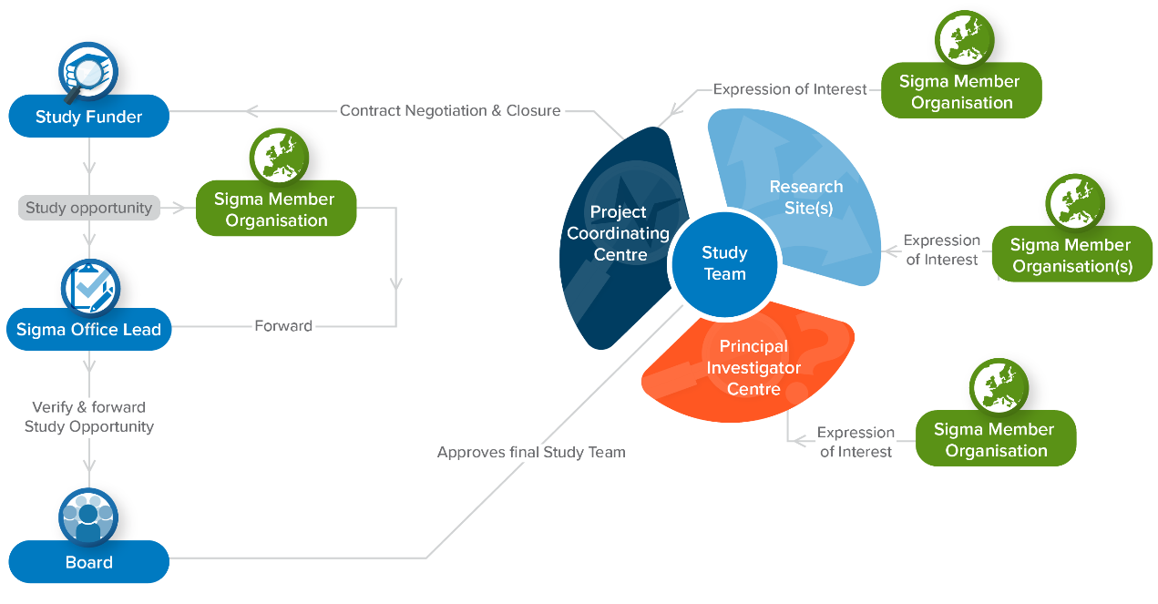
Adapted with permission from VAC4EU (https://vac4eu.org/decision-making-and-roles-in-the-conduct-of-studies/)

When you complete this form your request will be forwarded to the SIGMA Office members at RTI Health Solutions (USA & Spain) and The PHARMO Institute (the Netherlands). The SIGMA Office will forward this request to the other Members of the Consortium for evaluation. Confidentiality within the SIGMA Consortium is covered through the Consortium Agreement among its Members and CDAs with Collaborators.

Study request information
Details study requester institution
*Request date:
*Name of organisation (including VAT or registration number):
Department:
Address:
*Name, degree(s) and job title of scientific contact:
*Email address:
Phone number with country code:
Name, degree(s) and job title of alternative contact (if applicable):
E-mail address:
*Study sponsor (if different than requester institution):
How did you learn about SIGMA?
Project details (as available)
Proposed brief study title:
*Type of request (check all that apply): | Feasibility evaluation  Protocol development  Study implementation
*Proposal due date:
*Therapeutic area:
*Type of study: | Safety  Utilization  Effectiveness  Other Epidemiology (describe):
*Drug/device/intervention name(s) (as applicable) and ATC code (if available):
*Study is requested by an authority?  If yes, please name and list any agreed regulatory milestones: | No  Yes – Name:  – Timelines:
*Study background and rationale:
*Objectives:
*Study design and setting:
*Study timeline (i.e. conduct of study):
Study period (i.e. data availability period):
*Target population:
*Outcome measures:
Planned data analyses (if known):
*Countries of interest (check all that apply): | Denmark Italy  France Spain  Germany United Kingdom  Netherlands Sweden  Other (please specify):  Unknown (please explain):
Main expected deliverables (if known):
*SIGMA Coordinating center preference: | No specific preference  (If preference) please name:
*Do you agree to run the study according to ENCePP Code of Conduct (SIGMA requirement)? | Yes
Other comments/remarks:
Study concept, protocol (synopsis or full), statistical analyses plan or any other relevant documents as available added: | Yes
* Required information

Please return a digital copy of the completed form to: info@sigmaconsortium.eu

By submitting this form you consent to the processing and storage of your personal data by the SIGMA Consortium Members. In compliance with the current data protection legislation, we inform you that your data is incorporated into files owned by RESEARCH TRIANGLE INSTITUTE (USA & Spain) and The PHARMO Institute (the Netherlands) for the purposes of sending communications related to our services and facilitating the SIGMA Consortium’s business activities. To exercise your rights as provided for by law, the owner of the information can contact the SIGMA Office in writing, Subject: Data Protection, by sending an email to info@sigmaconsortium.eu. Please see our full website privacy policy here

